

Advancing a Sustainable Scottish Supply for Sugar Beet
–Field Trialling Sugar Beet in Eastern Scotland
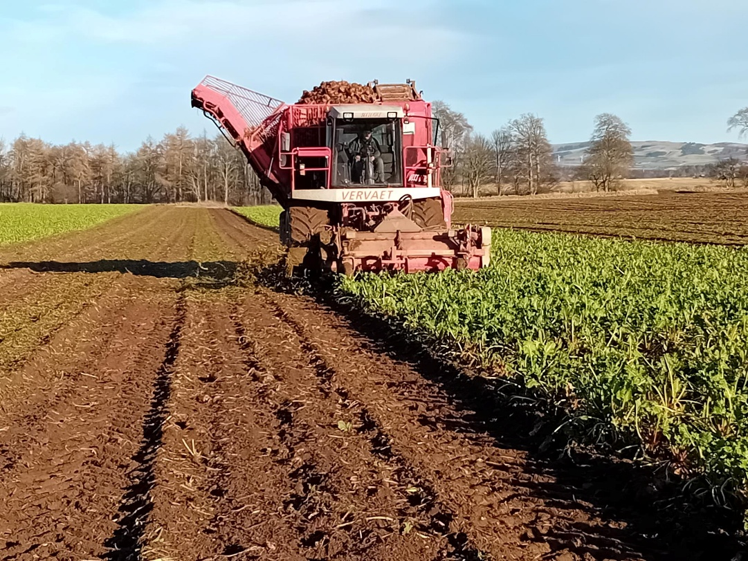


Commissioned by:

The Industrial Biotechnology Innovation Centre
Scottish Enterprise

Author:
Iain Riddell (Iain.Riddell@sac.co.uk), Principal Consultant, SAC Consulting
Published Date: 24th March 2025
Contents Page

- Introduction......................................................................................................1

- Acknowledgements...........................................................................................1

- Executive summary…………………………………………………………………………………….1

- Recent studies of Scottish sugar beet potential.……………………..……………………..3

- Sugar beet production in Scotland – past, present, and future potential...............4

- Project objectives……..…..…………………………………………………............................6

- Farm sites….......................................................................................................6

- Sugar beet varieties……………………………………………………………..…….…..…………..8

- Trial protocol......................................................................................................8

- Trial results.......................................................................................................10

- Pictures of crops and harvesting………………………………………………….………………14

- Climatic considerations....................................................................................17

- Conclusions.....................................................................................................19

- Webinar.………………………………………………………………………………………..….…..…19

Appendices.......................................................................................................20

Cover picture – A sugar beet harvester in action at Stracathro Estate, Brechin, early February 2025
1. Introduction
Funded by the Industrial Biotechnology Innovation Centre (IBioIC) and Scottish Enterprise, and delivered by SAC Consulting, this project was set up to gain additional information on the performance and potential of sugar beet in Scotland through field trials and observations. The project was conducted in the 2024-25 growing season with the final yield and sugar assessments made in February 2025. It followed work undertaken in a 2021 Viability Study into the potential of growing sugar beet for industrial purposes and 2022 farmer focus group meetings.
2. Acknowledgements
- Funders IBioIC and Scottish Enterprise for funding for both this project and previous development work.
- Special thanks are due to the four farm businesses who provided land for our trial strips – Andrew Booth at Savock Farms, Iain Wilson at Stracathro Estate, Ross Foster at Peacehill Farming and Sion Williams at Buccleuch Estate.
- KWS UK Ltd for supplying Harryetta and Katjanna sugar beet seed for sowing at the four farm sites and assistance in interpreting results.
- Gordon Cairns, Independent Consultant, for assistance in project organisation and agronomy input.
- SAC Consulting staff, Mark Bowsher-Gibbs, Alastair Bealing and Captiva Mills and Stracathro Estate, Gordon Cairns and Iain Wilson for assistance in harvesting the trial sites at Ellon, Brechin and Selkirk.
- Scottish Agronomy staff, Douglas Drysdale and team, for harvesting and assessing the trial site at Balmullo, St Andrews.
- The British Beet Research Organisation (BBRO) for assistance with trial protocol and sugar analytical services.
3. Executive Summary
Sugar beet was widely grown in Scotland from 1926 to 1972 with the Cupar plant processing crop from 6500ha (16,000 acres) for sugar production. Currently, a few farmers grow sugar beet along with fodder beet as a feedstock for Anaerobic Digestion plants.
There is an urgent need to find scalable and sustainable biobased feedstocks to replace fossil fuels for manufacturing chemicals and bioplastic products. A previous study, “A Just Transition for the Chemicals Sector and a Net Zero Solution for Manufacturing, November 2021”, revealed that it would be possible to grow domestic sugar beet to displace a percentage of fossil fuel-based manufacturing in Scotland. Given the range of crops that can be grown in the Scottish climate, and ease of sugar extraction, sugar beet is one of the best sources of biomass for manufacturing chemicals and bioplastics in Scotland.
Our trial used four farm sites on the eastern side of Scotland. Sites near Brechin in Angus and St Andrews in Fife situated in the preferred sugar beet growing area, and two outliers, Ellon in Aberdeenshire at a more northerly latitude, and Selkirk in the Scottish Borders. Two sugar beet varieties were sown at each location with harvest assessments undertaken in October, December, and February, to track yield and sugar content over a harvest season.
Results confirmed that sugar beet continued to grow from October to December on all sites, before plateauing or decreasing slightly from December to February on three of the sites. Highest yielding was the Fife site peaking at an excellent average of 87 tonnes per hectare in February, with the Angus site peaking at 66 tonnes per hectare in December. A cool wet spring delayed sowing until early June, which is exceptionally late, on the Aberdeenshire and Borders sites with peak yields averaging just over 50 tonnes per hectare. The Borders site contained a significant percentage of fodder beet and is not representative of sugar beet performance. Sugar content was around 16.5% or higher in Aberdeenshire, Angus, and Fife, which is similar to average English beet results for the season.
Evidence from previous farm weighed trials and average farm yields suggests that yields of 60 to 65 tonnes per hectare can regularly be obtained in the preferred beet area, in Angus and Fife, on prime arable land with class 1,2 and 3.1 soils. Perth and Kinross, Lothians and Borders with similar soils and climate are also suitable for sugar beet production.
Farmers are keen to grow another break crop provided that it is profitable. The net margin of growing sugar beet would need to be as good as, or better than, their current best performing crops, and some guarantees would be required that there was a long-term market for their beet, to justify investment in new equipment and risk of trying a new enterprise.
Sugar beet can be in the ground for up to ten months from Late April/May to February and has proved to be a resilient crop withstanding periods of drought, excessive rainfall, and frost (provided there is adequate leaf cover). The bigger question for Scotland is scaling up production and whether we have enough harvestable days to be able to lift crop without risking soil structural damage in challenging conditions. This would not have been a problem in the mild, dry winter of 2024-25, but the excessively wet October to December of 2023 would have been problematic.
The previous Viability Study envisaged a plant processing beet from around 15,000 hectares of land feeding a centralised processing plant. This is unlikely to work at this scale, as this requires almost 50% of the available prime land in a one in six crop rotation within 50 miles of the site and could be difficult to harvest in a problematic winter. A smaller scale enterprise of say 5,000 hectares, or a series of distributed hubs, supplying concentrated sugar syrup for higher value manufacturing market, would make best use of the available land. This scale of operation has yet to be costed and assessed for viability.

4. Summary of recent studies of Scottish sugar beet potential
4.1 Previous Viability Study
The need for a scalable, sustainable biobased feedstock for the chemicals and industrial biotechnology industry has become more critical recently as the Scottish and UK Government have set a net zero mandates for 2045 and 2050, respectively.
A previous 2021 study funded by Scottish Enterprise (SE) explored the techno-economics of reintroducing sugar beet as a sustainable biobased feedstock to replace petrochemicals in the production of biofuels and polyethylene. This study revealed it would be possible to grow domestic sugar beet to displace a sizeable percentage of fossil fuel-based manufacturing in Scotland. As a follow up to this study, the report authors organised a series of farmer focus groups to gain farmer feedback and identify next steps. To further support the realisation of this project, a key outcome was the need for robust crop trials to demonstrate that sugar beet crops can perform in eastern Scotland, thus giving farmers confidence in growing this crop.
The 2021 Study – A Just Transition for the Chemicals Sector and a Net Zero Solution for Manufacturing delivered by the Industrial Biotechnology Innovation Centre (IBioIC), SAC Consulting (part of SRUC), and SAOS can be accessed by using this link. https://www.scottish-enterprise.com/learning-zone/research-evaluation-and-insight/2021/sugar-beet-a-just-transition-for-the-chemicals-sector-and-a-net-zero-solution-for-manufacturing
4.2 Farmer Focus Group Meeting findings
The main comments arising from the three farmer meetings and a follow up survey, held in May 2023, were as follows. Twenty farmers attended two arable and potato co-op meetings with an additional thirty-five attending an online meeting to learn about and comment on the potential of setting up a Scottish sugar beet supply chain.
- Sugar beet needs to be the most profitable crop in their rotation to attract farmers to grow it, and there needs to be some allowance for the risks involved in growing a new winter harvested crop, as well as an allowance for industrial carbon savings generated on farm.
- Farmers suggested that the price should be at least £50/tonne, based on current crop margins, otherwise the potato growers, a key “influencing” group, would be unlikely to participate. A pricing model needs to be developed which accounts for volatility.
- Several farmers commented that the indicative target of 16,600ha or one million tonnes of beet, was ambitious. This would require supply from a broader area than the East and Southeast of Scotland perhaps through satellite processing hubs.
- The threat of Scottish beet supply being undercut by ethanol imports needed to be investigated at an early stage.
- Farmer concerns included - impact on soil structure of wet harvesting conditions, losing crop to frost or adverse weather conditions, the risks of spreading soil borne pests and diseases particularly for potato growers, and impact on other crop markets.
- It was concluded that trials should be set up for spring 2024 to identify best agronomic practice and help convince farmers the crop can be grown in different areas and soil types, before and during the detailed feasibility work phase.
- When asked to assess their interest in the proposal, at this early stage, 86% of farmer survey respondents had some interest or more in the proposal, 60% were either interested or very interested, with only 13% not interested. Sample size – 23 survey respondents.
5. Sugar beet production in Scotland
5.1 The British Sugar years
Sugar beet was grown in Scotland from 1926 to 1972 as part of the British Sugar Corporation. Beet was processed into sugar at a processing site in Cupar, Fife, which benefitted from a ready supply of water from the nearby river Eden and rail links to a wide area of the east coast from Easter Ross down to Northumberland. The plant was designed to process beet from 16,000 acres, or approximately 6,500 hectares and employed up to 500 people. Scottish yields at that time were at best 15 tons per acre (37 tonnes per hectare) by the mid 1960’s, averaging around 11 tons per acre (27 tonnes per hectare).
By the mid 1960’s, the operation was in decline with the beet acreage having reduced to 7,000 acres, and despite an acreage revival the decision was made to close the Cupar factory in 1971. Several reasons are given for its demise, including factory losses due to reduction of government subsidies, reduced supply due to removal of transport subsidies, less attractive prices and the impact of an exceptionally cold winter of 1963 and some poor crops in subsequent years. Several UK plants were closed as the British Sugar Corporation consolidated its operations in southeast England. Announcement of the Cupar factory closure was met by considerable disappoint as Fife had lost a major employer and east coast arable farmers lost a reliable break crop, ironically at a time when sugar beet growing had becoming much easier through the introduction of monogerm seed, effective herbicides, and more efficient farm machinery.
Figure 1 - Unloading beet at the Cupar factory
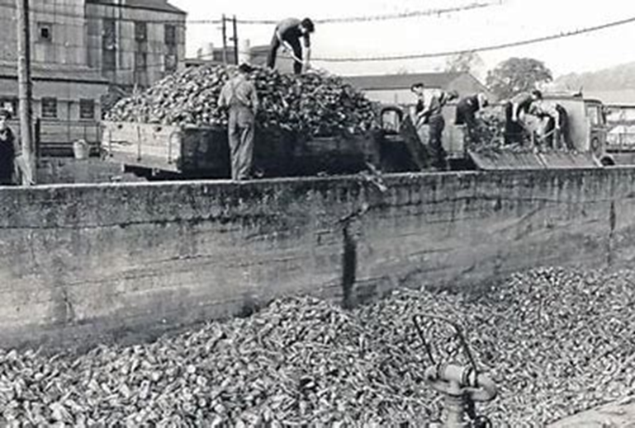

5.2 Present day use of sugar beet
Breeding programmes have led to significant improvements in sugar beet yields in the period since the crop was last grown in Scotland. A few Scottish growers have grown sugar beet in recent years as a feedstock for their Anaerobic Digestion (AD) plants generating heat and power for the energy grid. This has provided several years of evidence that the crop can thrive in Scottish conditions.
Prior to the 2021 study, in spring 2020, a Sugar Beet Working Group established small-scale observation plots at the James Hutton Institute, Dundee, and farm scale trials on four farms running AD plants. On each farm, 0.25 hectare bags of seed were obtained for five sugar beet varieties. Each demo site followed the individual farms agronomy regime and harvested crop weight was assessed on a weighbridge. The Brechin and Fife demo crops averaged 68 and 63 tonnes per hectare respectively with Aberdeenshire at 58 tonnes per hectare and the drought affected Borders site averaging 50 tonnes per hectare across all five varieties. This combined with other farm yield weighbridge data gave confidence that yields of 60-65 tonnes per hectare should be achievable in the main beet growing area of Angus and Fife.
This can be compared with “average” British Sugar SE England yields of 75 tonnes per hectare ranging from 69-84t/ha in the seven years up to 2019. Sugar beet yields vary season by season, hence the need for more information on Scottish potential.
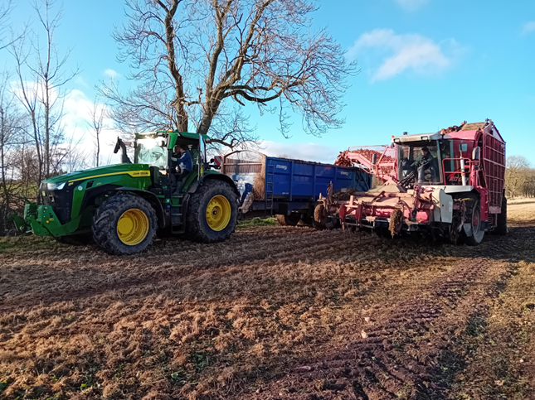
Figure 2 Beet harvesting at Brechin, filling a trailer from the harvester, February 2025

5.3 Future potential in Scotland
There has been a significant long-term improvement in sugar beet yields and calls to seed houses and BBRO suggest that this trend is likely to continue, thanks to new emerging varieties. This study has confirmed that sugar beet can be successfully grown in Scotland and further “local” trialling will be required to evaluate current varieties in the prime sugar beet growing area. And, for the crop is to be grown on a large scale, agronomy expertise will have to be gained, and operational logistics overcome before yields can approach their optimum level.
Climate trends are also a factor. While Eastern Scotland generally avoids the consequences of serious summer drought, climate change is already impacting on Southern English production and there is some thought that the crop may have to expand further north in the longer term. And if a trend to milder but wetter winters develops does this impact positively or negatively on the number of available harvest days through a Scottish autumn and winter?
6. Project Objectives
- Investigate the impact of location on yield and sugar content by establishing strips of the same beet varieties at four sites on the Scottish East coast arable area in Aberdeenshire, Angus, Fife, and the Borders.
- Track yield and sugar percentage throughout autumn and winter by harvesting beet at three timings at each site in October, December, and February.
- Record observations from each crop site from sowing through to the final harvest, on any issues that crops faced and analyse available weather data.
- Record the number of harvestable days between late September and late February when sugar beet would be harvested to help assess the implications of growing the crop at scale to feed a chemical supply chain.
- Hold a Webinar in March to disseminate information and to invite feedback.
- Issue a Final Report on the project findings by 31st March 2025.
7. Farm sites
The original intention was to site our trial areas on the same farms as the previous 2020 farm yield study. The central Borders site used previously had stopped growing beet, so Buccleugh Estate kindly stepped in. Our four host were:
- Savock Farms Ltd, Newburgh, Ellon, Aberdeenshire
- Stracathro Estate, Brechin, Angus
- Peacehill Farming Ltd, Newport-on-Tay, Fife – site at Balmullo, St Andrews, Fife
- Buccleuch Estate, Bowhill, Selkirk, Borders
Of the four, only the Brechin and St Andrews sites would be regarded as being within the core sugar beet growing target area. Both these businesses have a history of growing beet, including some varieties of sugar beet, as a feedstock for their AD plants over several years. The Ellon site is an outlier in terms of its more northerly latitude – little sugar beet was grown in this area from 1926-72. The Selkirk site is even more of an outlier being located at higher altitude of close to 150m (500 feet) above sea level in a livestock dominated area, which was thought to be a good test of the crops hardiness.
Table 1 Farm sites and sowing dates
Site¹ | Soil type | Height ASL² | Sowing date
Ellon | Silt loam | 56m (184ft) | 3rd June
Brechin | Sandy loam | 40m (131ft) | 30th April
St Andrews | Sandy silt loam | 24m (79ft) | 13th May
Selkirk | Sandy loam | 150m (492ft) | 6th June
¹ Nearest town ² Height above sea level for specific trial field

Note that these are field trials rather than randomised plots, which would have been too costly for the project budget given the dispersed locations of the sites.
The following map shows locations of the four farm trial sites and the availability of prime arable land on the east and northeast coast of Scotland. The farm sites are represented by red stars on a map created for the 2021 Viability Study to identify the most suitable arable land for sugar beet around five current Anaerobic Digestion plant locations. GIS analysis was used to identify areas of Grade 1 (brown), Grade 2 (yellow) and Grade 3.1 (green) land using the Macaulay Land Use Capability data, upgraded for subsequent changes to land use.
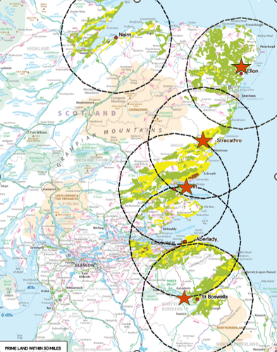
Figure 3 - GIS mapping of prime arable land with farm locations identified by red stars.
Choice of trial area was each farmers decision. We did not want the trial to interfere with farmers sowing operations, and the trial strips tended to be sown in a small field or the end or corner of a field. Tractor drivers cleaned out the seed drill to sow the trial strips with the instruction being a minimum of four rows per strip using a 0.25ha pack per variety.
This worked well for three of the sites. Unfortunately, contamination by fodder beet “rogues” affected the Selkirk site, sown by a contractor, with up to 30% fodder beet plant count for Harryetta and 12% for Katjanna. We continued to record yield and monitor this site, but it is not a true reflection of sugar beet performance.
Sowing dates were significantly delayed by a cold, wet spring, and early summer. Normally fields would be sown from late April to mid May. Brechin strips were sown within this period on 30th April, thanks to a light, sandy loam soil. The heavier St Andrews site was late sown by the farms standards on 13th May. The Ellon site was sown using the Stracathro drill and the late sowing was down to the seedbed not being ready to sow until 3rd June – exceptionally late. Likewise for Selkirk where sowing was delayed until 6th June.
Agronomy was down to the farmers normal agronomy as it would have been too costly and impractical to prescribe identical treatments. Details of each farms treatments can be found in the Appendix 1.
8. Sugar beet varieties
Two sugar beet varieties were supplied by KWS.
Descriptions from the KWS website. Note that sowing date comments apply to SE England.
Harryetta
- Jointly the second highest yielding BCN tolerant variety for 2025
- Low bolting
With low bolters in both the normal and early sown windows combined with very high yields HARRYETTA KWS will again be a highly sought after variety for 2025 - whether BCN is an issue or not.
Katjanna
- Top 3 yield performer
- BCN tolerance
- Low bolting
After 4 years KATJANA has gained a loyal following by growers. It offers a good combination of high yields paired with BCN tolerance. It is a well-rounded variety, offering growers the ability to be sown before mid-March and has the highest sugars, in the BCN segment.
9. Summary trial protocol
Two varieties – KWS Katjanna (K) and KWS Harryetta (H) – to be sown at each farm.
Undertake test digs and calculate an average yield in tonnes/ha for each variety on each farm, at each assessment timing – October, December, and February. Send a representative 15kg sample for each variety, at each assessment timing to BBRO for sugar analysis.
- Target sample timings:
  - Mid October – to measure early harvest yield
  - Mid December – to measure peak yield after bulking up
  - Early February – to measure late season yield
- Due to variability in crop growth within fields we should sample a minimum of four replicates for each variety at each assessment date. Replicates consist of two adjacent 4m rows (4 square metres at 50cm between rows) - this reduces the risk of 1 row being in a wheeling or mechanically affected. Four replicates will consist of 4 x 4m x 2 rows = 32 linear metres for each variety at each site.
- The harvested yield is intended to be representative of part of a field rather than complete field yield.
- Sowing to be done as a minimum of 4 rows for each variety in the seed drill depending on shape of field.
- Sample points to be roughly as follows; first sample 25m into row, second sample +35m, third +35m and fourth +35m where only one strip available. Sample middle two of four rows, avoiding tramlines. Sequential digs from end of previous sample plot.
- When harvesting, slacken off roots with a fork, hand lift, clean and cut off shaws at the crown keeping rest of beet intact. Carry of the field in bags.
- Record plant count per replicate (per 4m²).
- Beet to be power washed to get rid of most soil before being weighed. Spring balance scales on tripod or electronic weigher to be used.
- Weights to be recorded for each replicate numbered H1, H2, H3, H4 or K1, K2, K3, K4 to compare variability of replicates.
- One composite 15kg sample of beet for each variety to be bagged and sent to BBRO for sugar analysis at each assessment timing.
Figure 3 From left to right - Harvesting a 4m² replicate, Power washing the sugar beet, Weighing sugar beet yield
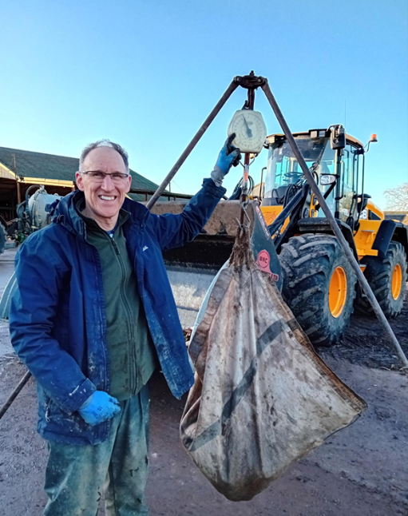
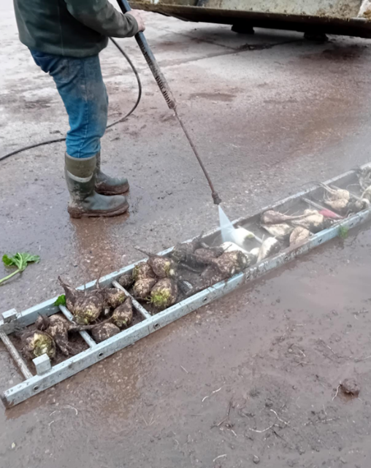
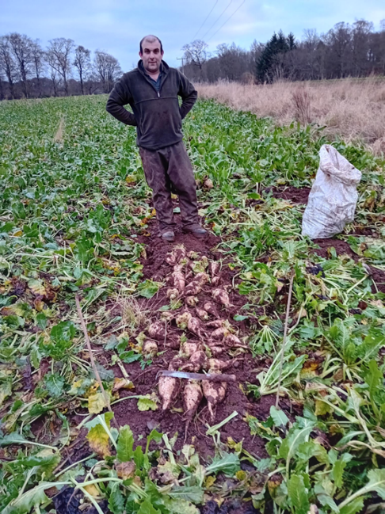

10. Results
Plots were hand harvested as close to the target timing as was practical for the harvesting teams. Ellon and Brechin were harvested by SAC Consulting and Gordon Cairns, St Andrews by Scottish Agronomy, and Selkirk by SAC Consulting.
10.1 Before presenting the trials results the following comments need to be noted:
- Late summer/autumn drought impacted on the Brechin site, on a sandier soil, leading to leaf mottling and poorer than normal summer growth. This field is normally one of the better performers on this farm.
- Unfortunately, no record was kept of the sowing plan for the two sugar beet varieties at Balmullo, St Andrews. A best guess was made of which was Harryetta and which was Katjanna.
- All sites lost some yield to deer grazing in December and February assessments – this was most noticeable at Brechin and Selkirk.
- The Selkirk results should be discounted as a sugar beet trial as there was a high level of fodder beet contamination in the Harryetta plots with Katjanna slightly less contaminated.
- Hand lifted yields are likely to be higher than beet harvester yields as they include small beet and the full root without any harvesting breakages.

10.2 Crop yield and harvest date
Table 2 Sugar beet yield by variety and harvest date

Table 2 shows results for both varieties, Harryetta and Katjanna, for each of the three harvest timings. Each individual result is the average of 4 x 4m2 replicates. While Harryetta and Katjanna performance fluctuated either way, there were no consistent yield differences between the two varieties. Seed provider KWS commented that that they would not expect to see much difference as the two have recorded similar yields in Recommended List trialling. We have therefore amalgamated the two varieties results as a guide to overall sugar beet performance in following tables.
The next two tables summarise averaged sugar beet variety results for each farm location and harvest timing, with plant count data.

Table 3 Bar chart of average sugar beet yield for each harvest timing
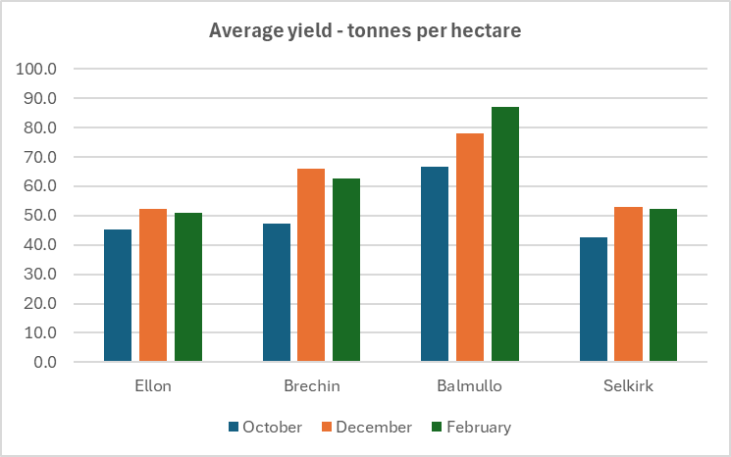

Comment on results
Savock, Ellon – beet yield for this late sown beet crop lagged behind the Fife and Angus crops. From an initial 45.3 tonnes per hectare, yield increased by 16% to 52.4 tonnes per hectare by mid-December, then falling back 3% to finish at 51.0 tonnes per hectare in early February.
Stracathro, Brechin – summer growth was impacted by drought and the October assessment yielded a disappointing 47.3 tonnes per hectare, improving by a substantial 40% to 66.1 tonnes per hectare by mid-December. Yield fell back by 5% between December and early February assessments.
Balmullo, St Andrews – this crop got off to a good start and maintained growth through the assessment period. From a good 66.8 tonnes per hectare average in October, yield increased 17% to 78.0 tonnes per hectare in mid-December, and by a further 11% to an excellent 87 tonnes per hectare by the end of January.
Bowhill, Selkirk – this was the latest sown crop (6th June) grown at the highest altitude (approx. 500 ft) in a haugh field in a livestock area. There was also a degree of fodder beet contamination. October yield was 42.6 tonnes per hectare, rising 24% to 53.0 tonnes per hectare by mid-December, with a small 1% drop back to 52.3 tonnes per hectare by early February.
Ellon and Selkirk sites are outwith the recognised optimum sugar beet growing area and our trial confirmed that yields in these areas were lower than desirable when crop sowing had to be delayed in a late spring.
The Brechin and St Andrews sites, within the preferred sugar beet growing area performed reasonably well and very well respectively.
At Brechin, the crop recovered from the impact of a long dry spell through substantial late autumn, early winter growth, demonstrating the resilience of a sugar beet crop. This site is normally among the highest yielding fields in a normal year but a combination of low rainfall on a sandy soil led to soil moisture deficit up to September, while other fields on the farm performed better.
At St Andrews, the crop performed very well throughout. This is one of the “heavier” or siltier fields farmed by Peacehill, which could be problematic in a wet year. However, the soil retained moisture over the course of the dry summer and the plot yield outperformed other beet crops on the farm. This crop looked good throughout with excellent leaf cover and consistently large, uniform roots.
It is not unusual for sugar beet yields to increase in late autumn and early winter provided that the plants maintain green leaf area. Leaves tend to be lost in frosty weather, and regrowth takes place replacing the old leaves with new which uses up energy from the roots and contributes to decreases in yield from December onwards. The pattern of increased yield up to December with growth plateauing or decreasing thereafter is to be expected most years. The Balmullo crop was an exception in our trial with continued growth from October to February. This crop maintained a good leaf cover throughout, which may have driven the January yield gain.
10.3 Plant count and yield
Table 4 - Average sugar beet yields by harvest date and plant count per hectare
Plant counts were recorded for each replicate. The average root count for both sugar beet varieties is shown in the table above and converted into a plants per hectare figure.
According to the Sugar Beet Reference Book, published by BBRO (British Beet Research Organisation) “It is critical that plant populations do not fall below the target of 100,000 established plants per hectare in any part of the field if yields are to be maximised.” The same booklet also records average English plant populations by year and for the last five years the establishment figure has varied between 93,000 and 100,000.
Stracathro Estate at Brechin regularly sow 110,000 seeds per hectare and sowed both Stracathro and Savock, Ellon for the 2024 trials. The Ellon plant count worked out at 110,000 plants per hectare, which is perhaps on the high side, and resulting in generally smaller plants, although late sowing date clearly influenced on beet growth and size. The Brechin plant count was bang on target with 100,000 established plants. BBRO advise to sow 20% more seeds than the intended plant count. Gordon Cairns ,Stracathro experience has been that 10% more seeds works for the later Scottish sowing dates.
Ironically, the St Andrews crop with a low established plant count of 83,000 per hectare delivered the best plot yield by some distance. Plants were consistently big, compared to a wider variation in root sizes at Savock and Brechin.
Established plants at Selkirk were lower than BBRO target at 92,500 per hectare. We do not have a record of the target sowing rate for this field.
This is interesting information we would recommend that randomised plot trials take place to gain more information on the relationship between sowing rate, sowing date and plant establishment in Scotland.
10.4 Sugar content
The value of a sugar beet crop is influenced by both crop yield and sugar content. If we are to set up a supply of sugar for industrial use in Scotland, then it will be important to maximise sugar output per hectare. Sugar samples were sent by courier for each location, for each variety at each of the three assessment dates with analysis undertaken at the British Sugar tare house, where English beet crops are sampled prior to processing. A summary of other analysis of Amino N, Na and K is shown in Appendix 2.
Table 5 Sugar content of samples as percentage of fresh weight
Comment
Guidance provided by Martin Brown, Sugar beet specialist with seed supplier KWS, was that any figure of 16.5% or over would be regarded as an acceptable sugar content. A figure above this level would be even better if payment related to sugar content. Information from British Sugar plants indicated that they are averaging between 16.5 and 17.3% for this season. This suggests that our Ellon, Brechin and Balmullo results are consistent with English results.
Some variation can be seen in the table. The Selkirk sugar levels are low, possibly because of white fodder beet contamination – we sent only white roots thought to be sugar beet for analysis.
Despite late sowing the Ellon crops sugar values were close to 16.5%. Brechin results were good for the first two assessments but dropped to 15.9% in February. St Andrews results wre above 17% throughout.
No appreciable difference in sugar content was found between the two varieties. Variety information led us to expect Katjanna to have a higher sugar content than Harryetta. Our samples returned similar results with slightly lower sugar content in February results from Savock and Brechin.

11. Pictures of crops and harvesting
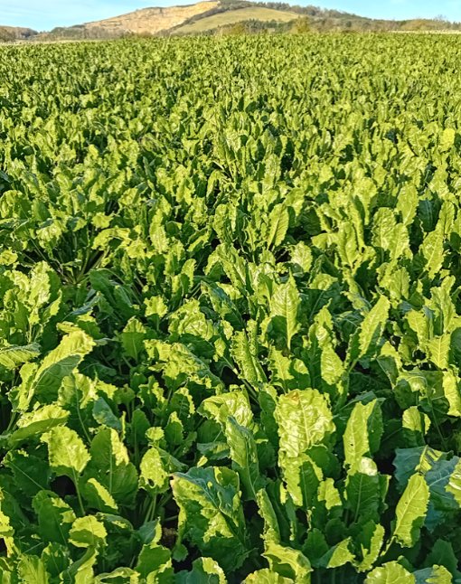
11.1 Balmullo, St Andrews

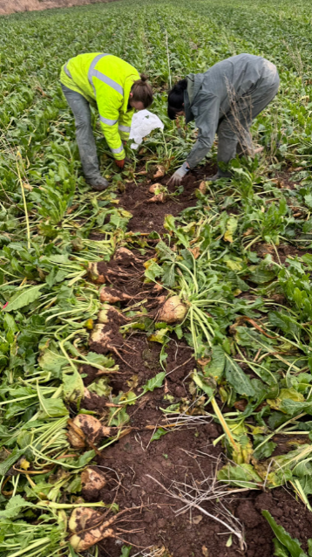

Figure 4. Good leaf cover and root growth throughout the assessment period. Pictures show from left to right – Crop growth in October, harvested beet in December, and the final harvest in late January. Maximum average yield 87 tonnes per hectare in late January.
11.2 Stracathro, Brechin
Figure 5
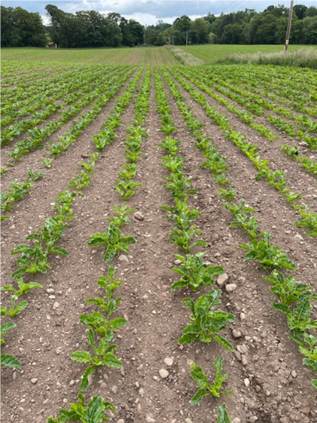
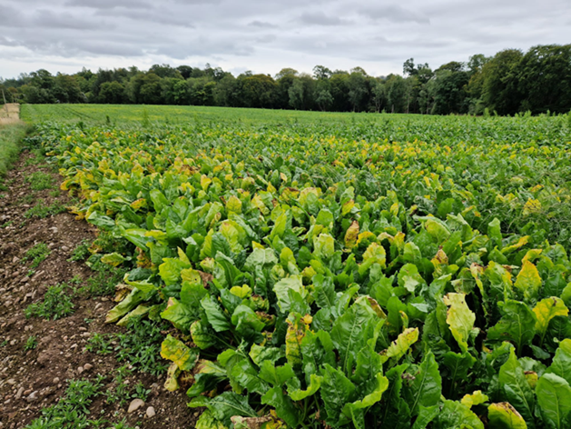

Good establishment from late April sowing. Leaves showed signs of drought stress in summer and early autumn, yellowing and mottling. Verified by leaf test and soil moisture deficit records.

Stracathro continued.
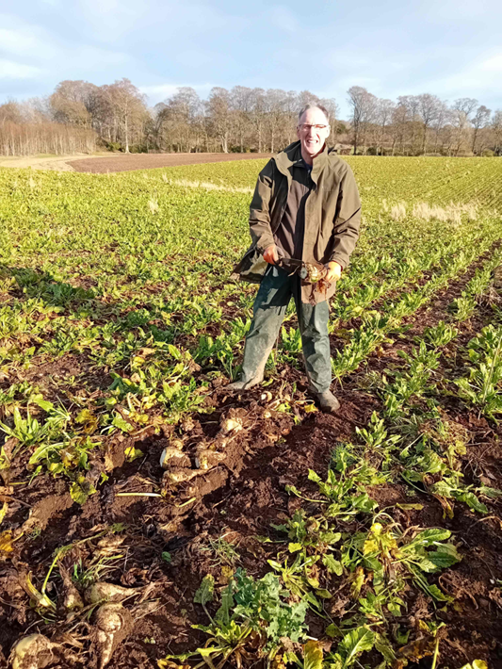
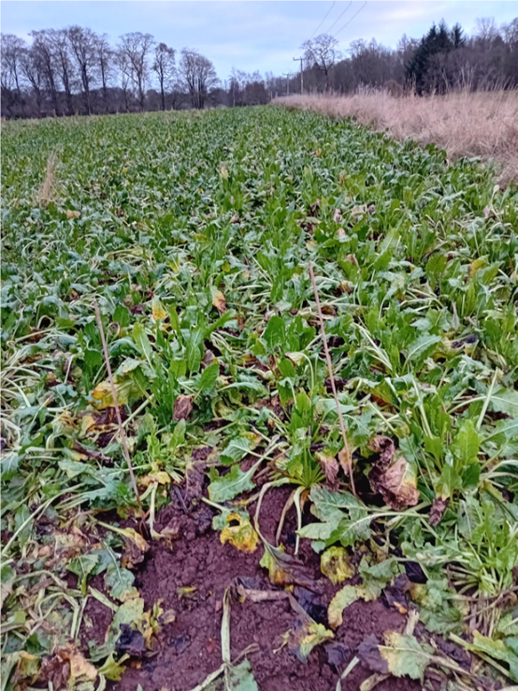

Figure 6. Pictures show diminishing leaf cover through new growth replacing previous leaves for left to right December and February assessments. Maximum yield 66 tonnes per hectare in December falling to 63 tonnes per hectare in February.
11.3 Savock, Ellon
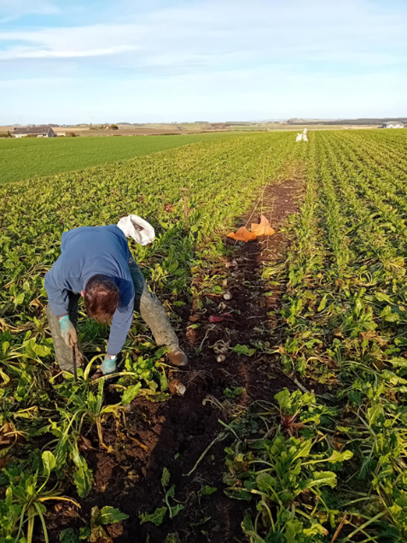
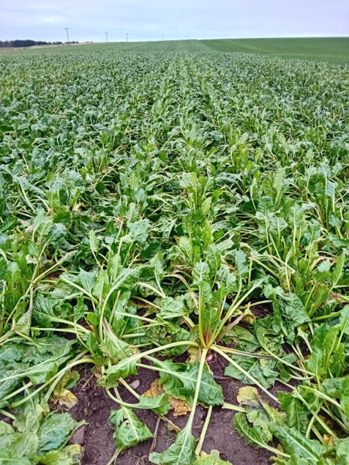
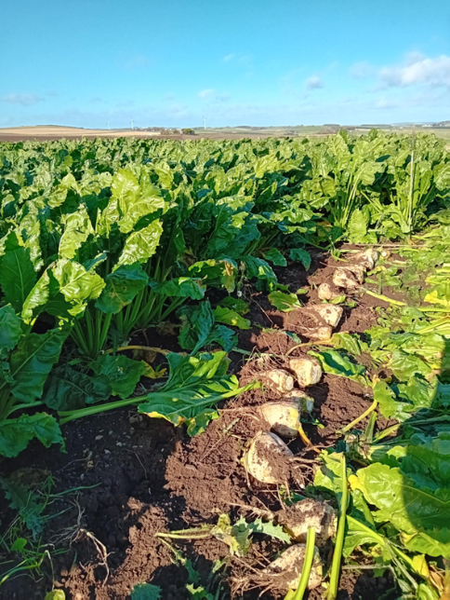

Figure 7. Left to right – October, December and February assessments. Reasonable leaf cover throughout but beet growth hampered by late June 3rd sowing date.

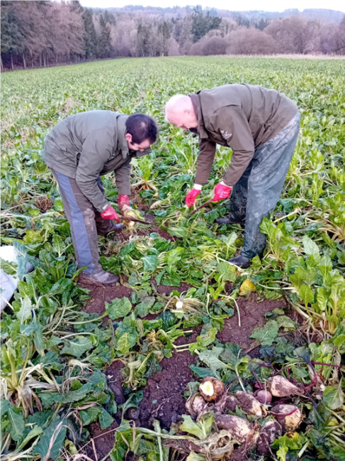
11.4 Bowhill, Selkirk

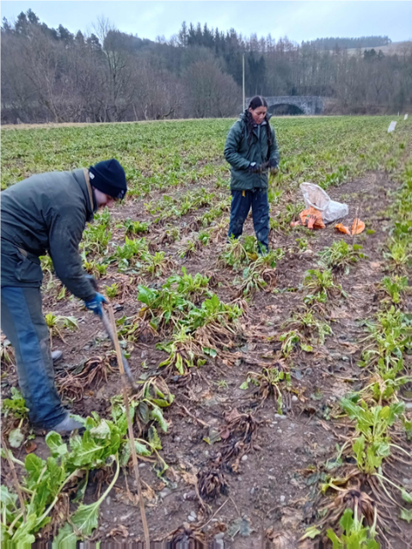

Figure 8. Left to right – Harvest assessments in December and February. High level of fodder beet contamination in some replicates and suspect some white roots may also be fodder beet. Note leaf and crown rot in February picture.
11.5 Sugar beet varieties
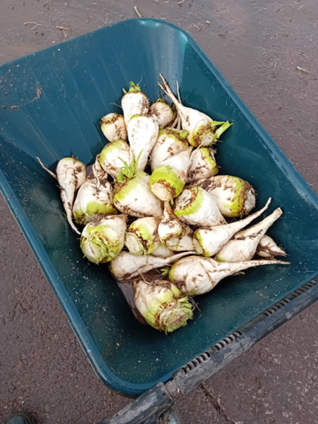


Figure 9. Left – Harryetta, right – Katjanna. Pictures from October harvest assessment.

12. Climatic considerations
How well is sugar beet suited to Scottish conditions? Grower evidence suggests that it can produce acceptable yields and be harvested without too much risk of soil damage in a wide range of climatic conditions.
The sugar beet crop is likely to be sown from late April to mid-May and can be in the ground up to February or ten months, experiencing a range of weather in all four seasons. It needs adequate rainfall to germinate and grow through the summer period and an adequate number of harvestable days in the winter when the soil is not too wet to avoid soil compaction issues when harvesting.
What does a typical sugar beet growing season look like? The previous five years rainfall records were obtained from the Leuchars MET Office station, which happens to be close to the Balmullo trial site, and one of the drier parts of Scotland. Light colours signify low rainfall and deeper blue high rainfall.
Table 6. MET Office data Leuchars 2020-2024

2024 featured a wetter than average spring, a drier than average summer, and an exceptionally dry spell from September to December. By contrast 2023 had a wet July and an exceptionally wet October to December. 2021 had a very wet May. There does not appear to be any consistent pattern in the rainfall data for this short five-year period.
We did not analyse temperature records, but the past five years have been notable for a lack of any severe winter weather and relatively few days of successive hard frost.
We asked our trial farmers to keep a record of harvestable or unharvestable days for the period October 2024 to February 2025 and the feedback was that there were very few days when beet harvesting was impossible in this exceptionally mild and dry winter. Going back a year to winter 2023-24 there were several periods when the ground was saturated. We held a Sugar Beet Open Day on at Stracathro Estate, Brechin on 15th November 2023, promising to demonstrate sugar beet harvesting, a promise that had to be renaged following two days of continuous heavy rain and flooding on the roads. However, three days later the farm was able to harvest beet, thanks to its relatively free draining soil. Farms with AD plants grow a limited area of beet and can pick and choose the dates when they harvest.
The Stracathro sugar beet harvester has low ground pressure tyres and a storage hopper holding around 16 tonnes of crop. It copes better with wet or soft ground than tractors and trailers, leaving minimal tyre marks in good harvesting conditions. To avoid compaction tractors and trailers can be left on the headland and filled up via the harvester hopper, with only the harvester working up and down the field.
Two conclusions we can make from this are:
- Care must be taken in selecting fields for sugar beet growing to ensure they are sufficiently free draining and not prone to waterlogging, to maximise winter harvesting opportunities and minimise risk of soil compaction.
- Number of unharvestable days could be an issue in some winters in Scotland if sugar beet were to be grown on a large scale, such as the 13,500 to 17,000ha required for a major central processing facility in the 2021 Viability Study.
Also, the 2021 study identified limitations of land availability, as shown in the GIS map in Figure 3. It is quite dispersed and calculations for a central plant in Grangemouth estimated that growing 13,500ha of sugar beet would require close to 50% of the available land, in a 1 in 6 rotation, within a 50-mile radius.
Table 7. Availability of prime land within a 50-mile radius of two locations.
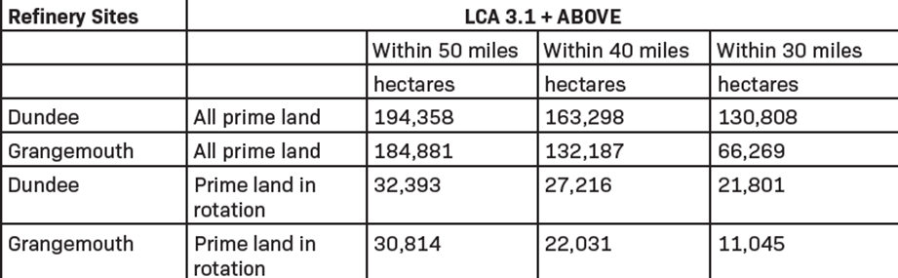
Returning to climatic factors, the following table shows the soil moisture deficit (SMD) recorded on Stracathro Estates from May to September 2024.
Table 8. Stracathro, Brechin, Rainfall and SMD 2024 – G Cairns
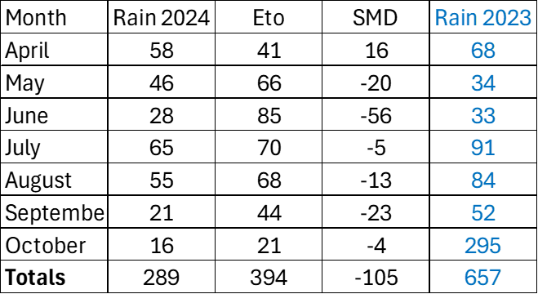
Evapotranspiration (Eto) or water loss exceeded rainfall from May until October, hampering summer and early autumn beet growth at Stracathro, although the crop recovered to produce a reasonable yield by December.
Sugar beet is resilient crop, and the long growing season allows an opportunity for yield to catch up after an adverse spell of weather.
13. Conclusions
Evidence from previous farm weighed trials and average farm yields suggests that yields of 60 to 65 tonnes per hectare can regularly be obtained in the preferred beet area, in Angus and Fife, on prime arable land with class 1,2 and 3.1 soils. Perth and Kinross, Lothians and Borders with similar soils and climate are also suitable for sugar beet production.
Farmers are keen to grow another break crop provided that it is profitable. The net margin of growing sugar beet would need to be as good as, or better than, their current best performing crops, and some guarantees required that there would be a long-term market for their beet, to justify investment in new equipment and risk of trying a new enterprise.
Sugar beet can be in the ground for up to ten months from Late April/May to February and has proved to be a resilient crop withstanding periods of drought, excessive rainfall, and frost (provided there is adequate leaf cover). The bigger question for Scotland is scaling up production and whether we have enough harvestable days to be able to lift crop without risking soil structural damage in challenging conditions. This would not have been a problem in the mild, dry winter of 2024-25, but the excessively wet October to December of 2023 would have been problematic.
The previous Viability Study envisaged a plant processing beet from around 15,000 hectares of land feeding a centralised processing plant. This is unlikely to be practical as it requires almost 50% of the available prime land in a one in six crop rotation within 50 miles of the site. This land is already growing other crops, and it would be hard to persuade hundreds of farmers to convert to sugar beet. 15,000 hectares could be difficult to harvest in a problematic winter with the need to provide a continuous supply to a factory. Beet can be lifted and stored on a hard standing for a few weeks in the middle of winter, but this does run the risk of losses to frost damage. A smaller scale enterprise of say 5,000 hectares, or a series of distributed hubs, supplying concentrated sugar syrup for higher value manufacturing market, would make best use of the available land. Distributed hubs serving a local area may make sense logistically, but this operation has yet to be costed and assessed for viability.
14. Webinar
A webinar held on Friday 14th March 2025 to publicise the study, and its results was had 30 participants including farmers, agricultural trade, agricultural consultants, and attendees from the biotechnology sector and government agencies.

Appendix 1 –Field and crop information
Savock, Newburgh, Aberdeenshire

Title | Comment
Farm name | Savock, Newburgh
Soil type  e.g. sandy loam | Clay loam
Previous cropping (5 years) | 2024 – Spring barley  2023 – Winter wheat  2022 – Grass  2021 – Winter rye  2020 – Spring barley
Cultivations and drill | Plough, power harrow, sugar beet drill
Sowing date | 3rd June
Seed rate  Kg/ha | 110,000seeds/ha
Fertiliser  NPK + other kg/ha | 30m3 liquid digestate  230l/ha of N29 + 12 SO3
Herbicide applications and dates | 05/06 Volcano 1.9l/ha + Jupiter 1.9l/ha  15/06 Volcano 1.0l/ha + Jupiter 1.0l/ha  16/07 Volcano 1.0l/ha + Jupiter 1.0l/ha
Any other treatments

Stracathro Estate, Brechin, Angus
Title | Comment
Farm name | Stracathro Estate
Soil type | Sandy Silt Loam  (Sand 40-45%, Silt 40-45%, Clay 10-15%
Previous cropping (5 years) | 23 – Grass 20 - Rye  22 – Grass 19 - Wheat  21 - Rye
Cultivations | Ploughed in spring  Tine/disc cultivator  Cambridge roll ahead of drill
Sowing date | 30/4/24
Seed rate | 110,000seeds /ha
Fertiliser | 550kg/ha - Laws Beet Base fert (0-0-13+35NA+boron) – Early March  350kg/ha – 23-15-0 – ahead of drilling  250kg/ha – 6-0-21 – at drilling  100kg/ha – 27-0-0+10SO3 – when rows meet
Herbicide applications and date | 4/5/24 – Pre emergence (1L Oblix +2L Defiant)  21/5/24 – Weeds 1 – (1.5L Jupiter +1.5L Volcano +10g debut)  29/5/24 – Weeds 2 – (1L Oblix + 1.5L Jupiter + 1.5L Volcano)  4/6/24 – Grass Weeds (1.3L Powertwin)  17/6/24 – Weeds 3 – (1.5L Jupiter + 1.5L Volcano)
Any other treatments | 4/6/24 - Laws Beet Trace elements mix  9/7/24 - Laws Beet Trace elements mix + 1L Floozy  15/9/24 - Laws Beet Trace elements mix

Peacehill Farm – Balmullo field, St Andrews, Fife
Title | Comment
Farm name | Hayston
Soil type  e.g. sandy loam | Sandy Silt loam
Previous cropping (5 years) | 2024 - Beet  2023 – hybrid rye for wholecrop  2022 - potatoes  2021 - rye  2020 – winter wheat
Cultivations and drill | Simba SL cultivator – 10th May into sprayed off cover crop  Lemken power harrow 13th May  Monosem precision beet drill 13th May
Sowing date | 13th May
Seed rate  Kg/ha | 100,000 seeds/ha
Fertiliser  NPK + other kg/ha | Liquid digestate @ 30m3/ha 20th April  Salt @ 320kg/ha 5th March  54kg N/ha liquid Nitrogen13.5kg/ha S
Herbicide applications and dates | Roundup cover crop 25 March  Roundup 16 April  Volcano herbicide, Backrow adjuvant 15 April  Jupiter, Volcano 23 May  Debut, devoid, cocoon, Toil adjuvant 6 June
Any other treatments | 3 fungicides  Angle, Magnesium 10 July  Angle, Magnesium 31 July  Caligula 1 September
Recent soil analysis  Ph  P  K  Other | Ph – 5.9 (2024)  P – Normal  K – High
Monthly rainfall record?  Is it possible to get information – March 2024 onwards? | Omnia software suggests 715mm between March 1st 2024 and Jan 7th 2025. Not sure how accurate that will be.

Bowhill, Selkirk, Borders
Title | Comment
Farm name | Bowhill , Selkirk  Wee Haugh field
Soil type  e.g. sandy loam | Sandy loam
Previous cropping (5 years) | 5 yrs grass
Cultivations and drill | Plough  Min till discs x 3  Drilled by contractor  Rolled
Sowing date | 07/06/24
Seed rate  Kg/ha | ?
Fertiliser  NPK + other kg/ha | 28/4 Deer FYM – 43t/ha  20/5 Liquid digestate – 7000gal/ha  Salt -333kg/ha  23/7 – Urea 46% - 200kg/ha
Herbicide applications and dates | 12/6 Backrow 0.5l/ha, Defiant – 3l/ha  2/7 Jupiter 1.5l/ha, Volcano – 1.5l/ha  29/7 Jupiter 1.8l/ha, Volcano – 1.8l/ha
Any other treatments | 30/8 Trace element Zoom – 3l/ha, Adjuvant Toil – 1.2l/ha
Recent soil analysis  Ph  P  K  Other | 2022  Ph 5.6 (calcium lime applied 2023 – 6.3t/ha)  P – target,  K – low,  Mg - high

Appendix 2 - Other sugar beet crop analyses
Amino N. Na and K
Results are in mg/100g of beet
