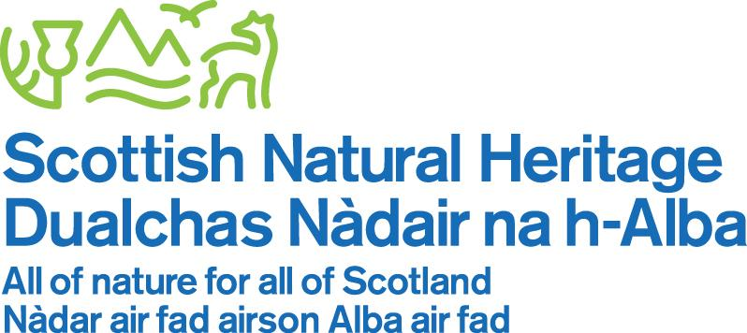

EAST LOTHIAN FARMING AND WILDLIFE WORKSHOP

Tuesday 29 May 2018 (9am – 12:30pm)

Lochhouses Farm, East Lothian

09:00 – 09:20 Teas/coffees (scones and pastries provided)

09:20 – 09:30 Introduction

- Welcome to workshop – purpose (Mike Thornton, SNH)

- Lochhouses Farm – Arable farming on the East Lothian coast – (Robert Dale, Lochhouses Farm)

09:30 – 10:15 Farming and wildlife

- What wildlife and habitats would you like to see on your farm?

- How have you created wildlife habitats on your farm and what improvements would you like to make?

- What are the biggest barriers to achieving this?

10:15 – 10:45 Working together

- How can we work better together beyond farm boundaries to deliver benefits for wildlife?

10:45 – 10:50 Summing up – (Tony Seymour, The Farm Environment Ltd)

10:50 – 12:30 Farm visit

- Tour of Lochhouses Farm to look at the implementation of environmental measures.

Directions to Lochhouses Farm and car parking
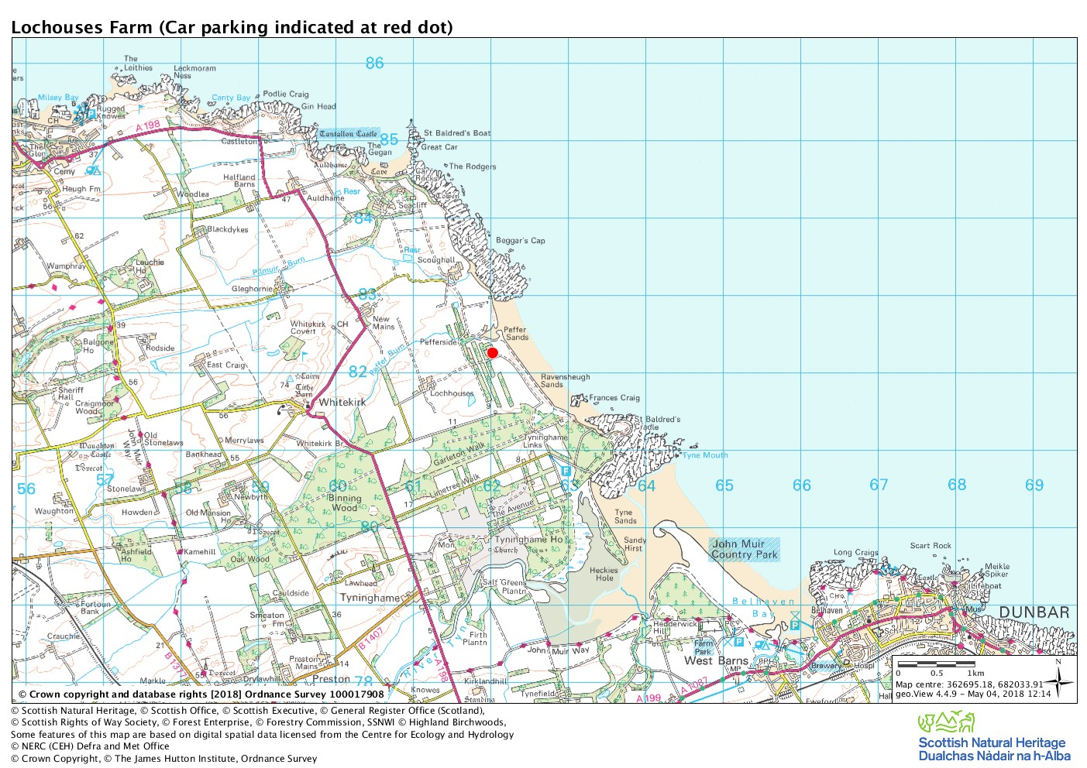

Please follow signs for Harvest Moon Holidays Marquee where you will find adequate car parking indicated by red dot on map.

