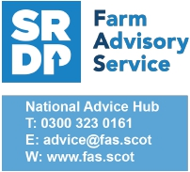
Reducing the risk of combine fires
With soaring temperatures prevalent and set to continue, those busy with harvest should be acutely aware of the risk of combine fires.
For the 2021 harvest, combine fire claims with NFU Mutual shot up by 35%.

Combine fires put lives at risk, result in crop loss and cause huge disruption at one of the busiest times of year.
As such, the Farm Advisory Service would like to make you aware of the fire prevention checklist from NFU Mutual that it is recommended all farmers follow to reduce the risk of combine fires:
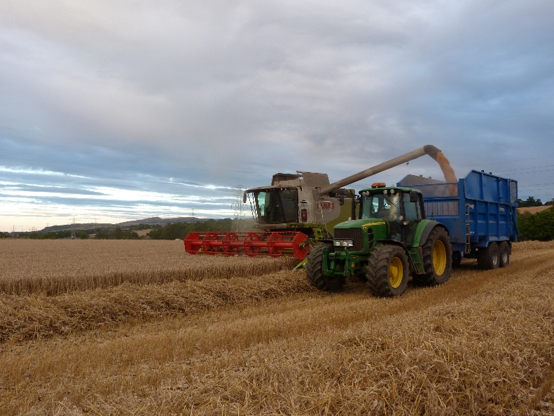
- Keep machinery maintenance up to date and ensure that it is in accordance with manufacturers service schedules.
- Regularly clean out dust and chaff from hot spots and check the machine over when you finish combining each day.
- Keep a fire extinguisher on the combine and ensure it is regularly maintained.
- Keep a filled bowser of water on hand and be prepared to create a fire break in the event of a crop fire.
- Always take the time to investigate hot-running engines or bearings.
- Fit a suppression system that meets P-mark status to contain, extinguish and prevent fire.
- Always keep a mobile phone on you and have a plan in place in the event of fire including a system for keeping in contact with lone workers and anyone working or living on the farm.
- Switch off engines and ensure moving parts have stopped before clearing blockages or carrying out maintenance.
- You can use a mobile compressor (or a fixed one if fitted to the combine) to regularly blow away debris from the machine, but only do so if the exit pressure is reduced (as a guide 30psi/2.1 bar is effective at cleaning). Wear eye and respiratory protective gear to protect from dust and never point an airline at a person to remove dust from clothing.
- Make sure drivers are aware of the locations and heights of power lines and check that you will safely pass under wires.
- Ensure you have the What3Words App downloaded to help emergency services find your location easily.

