One-to-one Farm Advisory Service
____________________________________________
April 2017- April 2018 Annual Report for Scottish Government
ED 61438 | Issue Number 1 | Date 16/04/2018
Ricardo in Confidence
Customer: | Contact:
Scottish Government | Caroline Wood  Ricardo Energy & Environment  18 Blythswood Square, Glasgow United Kingdom  t: +44 (0) 1235 75 3310  e: CarolineE.wood@ricardo.com  Ricardo-AEA Ltd is certificated to ISO9001 and ISO14001
Customer reference:
Farm Advisory Service
Confidentiality, copyright & reproduction:
This report is the Copyright of Scottish Government/Ricardo Energy & Environment. It has been prepared by Ricardo Energy & Environment, a trading name of Ricardo-AEA Ltd, under contract to Scottish Government dated 01/04/2016. The contents of this report may not be reproduced in whole or in part, nor passed to any organisation or person without the specific prior written permission of Scottish Government/Marc Addison. Ricardo Energy & Environment accepts no liability whatsoever to any third party for any loss or damage arising from any interpretation or use of the information contained in this report, or reliance on any views expressed therein.

 | Author:
 | Wood, Caroline E
 | Approved By:
 | Jamie Pitcairn
 | Date:
 | 16 April 2018
 | Ricardo Energy & Environment reference:
 | Ref: ED61438- Issue Number 1

Executive summary

In this second year of delivery we have sought to consolidate delivery, and significant work has been undertaken to promote the service to farmers and stakeholders.
Ricardo have worked to develop and implement a promotional plan for the one-to-one programme, to ensure that we are promoting the programme through all channels available to us; working with the press by issuing press articles; social media – providing a schedule of tweets and facebook feeds, direct mail to new entrants and promotion via advisers- encouraging this via the adviser newsletter and promoting referrals via stakeholders through attending stakeholder meetings, seeking speaker opportunities and the issuing the stakeholder pack.
In recognition of the importance of adviser to farmer interactions and trust in the take up of advice, Ricardo have worked closely with the advisers to ensure that training responds to adviser needs and that via the introduction of the advisers’ newsletter, advisers are kept well informed and involved in the programme
Looking at the results, the second year of delivery has been one of two halves. The feedback from service users has been excellent:

- 91% rated ease of access to information as excellent or good;
- 95% rated helpfulness at initial contact point as excellent or good;
- 92% rated ease of application process as excellent or good;
- 92% rate efficiency of scheme administration as excellent or good;
- 87% stated that based on their experience, they would recommend the FAS grants to other farmers;
- 96% rated the adviser’s working practices (helpfulness, understanding, expertise, etc) as excellent or good;
- 95% rated the quality of the report/support as excellent or good;
- 88% confirmed that they will implement all of the actions recommended.

It is clear that those who take up the advice find it to be of a high quality and really worthwhile to their business. This is supported by our experience of farmers who we have approached to take part in case studies. We have found real advocates, keen to share their good experiences with peer farmers.

However, uptake of support has slowed in the last 6 months and uncertainty around Brexit is creating a real hiatus in the industry with farmers holding back from making changes in their business. The real challenge for the programme in the coming year will be how to encourage farmers to move forward. There are excellent reasons to take advice now and review the business to ensure that when change does happen the business is as efficient as possible and in the best shape to deal with it. Ricardo will continue to work to address this challenge and look for every opportunity to encourage farmers to take up the support available to them.
Table of contents
1 Training 1
1.1 On-line training tools 1
1.1.1 Organics module 1
1.1.2 Biodiversity and Conservation module 1
1.1.3 Applying organic waste to land 1
1.2 Delivery of face-to-face training events 1
1.3 FBAASS adviser newsletter 2
2 Adviser FBAASS accreditation 3
2.1 Re-accreditations 3
2.1.1 Adviser Information 3
3 Review of reports 4
3.1 Standards setting 4
4 Promotion 5
4.1 Press articles 5
4.2 On-going content agreed 5
4.3 Promotional fliers 5
4.3.1 ILMP flier 5
4.3.2 Promotional postcards made available at trade stands 6
4.3.3 Support for new entrant’s flier sent as direct mail 7
4.4 Case Studies 7
4.5 Introductory slides 8
4.6 Show attendance 8
4.7 Stakeholder meetings 8
4.8 Direct mail 10
4.9 Social media feed 10
4.10 Stakeholder pack 10
4.11 Website 10
5 RSABI support 10
5.1 Volume of RSABI reports 10
5.2 RSABI pilot of feed resilience advice 10
6 Payment Mechanisms 11
6.1 Approach to payment 11
6.1.1 Overview of payment transfers 11
7 Template updates 11
7.1 ILMP template update- diffuse pollution SEPA 11
7.2 Application form updated to include details of ownership 11
8 Metrics of delivery during the year 12
8.1 Applications received 12
8.2 Reports complete 13
9 Feedback summary 14
9.1 Budgetary analysis 14

Training
The one-to-one programme provides training to advisers via the on-line training portal, via face-to-face training workshops and via ongoing communication through the advisers’ newsletter.

On-line training tools
All advisers delivering ILMPs are provided with access to on-line training resources built into an on-line training platform http://sfas.ricardo-aea.com/ During this year 4 new training modules were released:

Organics module
Two new organic farming training modules were developed with technical input from the David Michie (Soil Association). The first module provides advisers with a baseline knowledge in of organic farming principles, the inspection and certification requirements and financial support available order that they can discuss opportunities with farmers and provide signposting for more information. The second module provides more detail on the organic market, best practice and how to make organic farming work. The modules were uploaded to the adviser training portal and released to advisers in the May e-newsletter.

Biodiversity and Conservation module
Following discussions with SNH, Ricardo engaged the services of Richard Lockett (Agri-Environmental) to develop two new biodiversity training modules for advisers. This training takes advisers through a range of valuable habitats and provides training on how to recognise these habitats on farm, the value of the habitat and basic conservation methods. A key element of the training was to encourage advisers to have the confidence to start conversations with farmers about the value of what they already have on farm and simple measures to preserve and conserve it, advisers were provided with a tool kit of information to be able to provide signposting to further information. Face-to-face training on this module was rolled out at the adviser training during the last week of August. This training was extremely well received by the advisers. Richard Lockett and Tony Seymour who delivered the training sessions made the sessions relevant and engaging and received a round of applause from the attendees at the Stirling session. This is a real achievement considering the amount of negativity we received from advisers when biodiversity and conservation was brought into the ILMP

Applying organic waste to land
A 5th module- regarding the application of organic waste to land was developed during the year, this is still being finalised following review and comment from SEPA, this will be released in project year 2018-19.

Delivery of face-to-face training events
The adviser training sessions took place in the last week of August, achieving the attendance of 85 advisers which was very positive:
Venue | Date | Attendance
The Moffat House Hotel | Wednesday, 30th Aug | 30
Stirling Court Hotel | Thursday, 31st Aug | 29
Park Inn, Aberdeen | Friday, 1st Sept | 25

Agenda
- 10.30am to 10.35am: Welcome
- 10.35am to 10.55am: Delivery update, lessons learnt and frequently asked questions;
- 10.55am to 11.25am: Building on the strengths of the ILMPS - feedback from the review process
- 11.25am to 11.30am: short break
- 11.30am to 12.00pm: Interpreting results of carbon audits and providing meaningful actions
- 12.00pm -12.30pm Forestry Commission, Sheep and Trees Forestry Grant Package
- 12.30pm to 1.15pm: Lunch;
- 1.15pm to 2.45pm: Biodiversity and conservation training
The adviser training sessions were a real success, the feedback from the training was very positive and the attitude of advisers over the previous year has substantially changed. The advisors were notably more engaged and enthusiastic about the ILMPs. At sessions, last year we were faced with a lot of negativity regarding the changes from the Whole Farm Review. At this year’s sessions, the changes had bedded in and there were some real advocates in the room who were able to chip in with feedback on their experiences of delivering ILMPs. During the previous year, adviser’s focused on what they could not do with an ILMP, whereas this year they really did seem to appreciate the flexibility within the plan. The sessions on Forestry Grants were very well received, it was clear this was an area in which many advisers had little knowledge and from the session they clearly understood the opportunities woodland creation could offer to their farmers. As mentioned above, the biodiversity sessions were excellent. Most advisers in the room felt their knowledge of biodiversity and conservation was really centred on what was required for an AECs scheme application. The advisers really warmed to the themes and, in particular, the messaging around where biodiversity can be improved through no cost to the farmer, such as through reduced frequency or severity of hedge cutting.

FBAASS adviser newsletter
Ricardo introduced the FBAASS advisers’ newsletter as a mechanism for keeping one-to-one delivery in the adviser’s minds and incentivising action.
- The first e-newsletter for advisers was issued in March 2017 and reissued in April to any advisers who had not opened the first email. The newsletter provided advisers with an update on processes, news and information plus a summary or progress to date in terms of number of applications received and geographical data with the aim of keeping ILMPs etc. The newsletter opening rates were reviewed and reissued to advisers who had not opened it within 2 weeks. New issues of the newsletter will be issued every 2 months to keep advisers informed and engaged.
- The 2nd e-newsletter for advisers was issued in May. The newsletter focused on encouraging advisers to promote the FAS one-to-one services to farmers and ensuring this is at the front of their mind in late May when they may have a little more time available post-IACS submission. The newsletter also launched the new organics training module.
- The 3rd e-newsletter for advisers was issued in July, this newsletter focused on prompting advisers to reserve their place at the training events in August. It also and promoted the useful information in the publication ‘Valuing your soils’, providing web-links.
- The 4th e-newsletter for advisers was issued in September, this newsletter circulated the presentations from the adviser training and links to the new biodiversity training module. The newsletter also provided:
  - contacts at the Forestry Commission for farmers who are interested in woodland creation
  - details of a study SNH are conducting, looking for farmers to provide feedback on biodiversity issues and support
  - details of the CPD points required by Lantra at reaccreditation and the points available from attendance at the FAS training
- The 5th edition of the adviser newsletter was issued on the 31st January This provided advisers with a reminder on processes and guidance and links to the case studies and promotional articles that advisers can use to engage clients with the programme.
- The 6th edition, was slightly delayed avoiding the Easter holidays and sent on the 10th April. This provided advisers with details of the positive feedback received by advice recipients to date and links to case studies in order to encourage advisers to promote the benefits of the service to their clients. The newsletter also provided a reminder of procedures for submitting reports and claiming payments.

Adviser FBAASS accreditation

Re-accreditations
In April 2017 there were 88 full advisors and 21 associate advisors registered, a total of 109 registered advisors. At the close of March 2018, 75 full advisors and 17 associate advisors were registered at the end of the reporting period, a total of 92 registered advisors. 11 have chosen not to re-new. The advisers who discontinued had not delivered an ILMP in the previous year.

Adviser Information
During the year Ricardo issued the following information letters to advisers:
- April 2017: FBAASS advisers were sent a letter both by email and post to inform them of the state aid limitations.
- On the 14th November, all FBAASS advisers were informed of the decision to reduce the delivery window for ILMPs from 7 months to 4 months. This resulted in some concerns from Sinclair Simpson and Richard Huston. Advisers have been reassured that if there is a genuine farm-led reason that the report cannot be undertaken within this period then they simply need to contact Ricardo and the deadline will be extended, but we do expect these to be exceptions to the rule.

Review of reports
A new accreditation process was introduced in 2016, to quality check each advisor and create a clear benchmark for the standard which all advisors should achieve – this relates to both technical competences and style and use of language.
Our accreditation process is integrated into our quality assurance process. We conduct a ‘peer’ review process with first reports reviewed by a panel of peer reviewers managed by Lanta. The reviewers provide advisers with advice on areas for improvement (if required) and score reports against the following matrix:
Description | Technical  Score | Description
Report clearly lays out how scope has been met | 10 | Technical advice provided appears to fully meets client requirements
Report meets scope but not fully described in report | 9 | Technical advice provided appears to substantially meets client requirements
Report meets scope but only partially described in report | 8 | Minor omission in terms of technical advice
Report doesn’t cover one minor element of the scope | 7 | Significant omission in terms of technical advice
Report doesn’t cover or describe why one significant element of scope wasn’t covered | 6 | Major omission in terms of technical advice
Significant omission in terms of scope (e.g. primary focus of report not covered) | 5 | Wrong technical advice in one part of the report
Major omission in terms of scope (e.g. primary and secondary focus of report not covered) | 4 | Wrong advice throughout the report
Substantial omissions in terms of scope (i.e. majority not covered) | 3 | Serious technical errors in most of the report
Serious omissions in terms of scope (i.e. failure to address nearly everything) | 2 | Serious technical errors in all areas of the report
Nothing in report matches scope (i.e. none of the requested support provided) | 1 | Insufficient technical information in to allow any assessment (report generic not tailored to the client)

32 reports were peer reviewed in this period (all reports were reviewed by Ricardo). Of the 32, the highest scoring report received a 10/10, the lowest scoring report was a 4. 72% of first reports scored between 7-10. Only one report scored below 6

Standards setting
The Quality Review Group met on a quarterly basis throughout the year for a standard setting day. The group jointly review ILMP reports to ensure consistency between the group. During the year the group amended the report marking scheme to clarify terminology and ensure that reports could be marked down for providing an inadequate volume of advice, the previous ranking only looked at the quality of advice provided.

Promotion

Press articles
- Support Available, May 2017, press releases to promote the programme were sent to a full list of Farming publications, On the 13th May Farmers Weekly featured an article based on the FAS press release - http://www.fwi.co.uk/business/free-business-advice-and-support-for-scottish-farmers.htm
- Help with organic conversion. Following discussions with Robin Maclean, who was concerned that the number of farmers going into organic farming was declining, Ricardo developed a press release (issued on 12th Sept) to promote how the FAS one to one advice service can help to support farmers. Farmers looking to convert to organic can utilise the Integrated Land Management Plan and Organics specialist advice to access up to £2,200 of expert consultancy support which can be geared around developing an organics conversion plan for the business. This was picked up and published by the Scottish Farmer in September.
- Woodland development plan Following meetings with John Duggan and separately with Keith Wishart, (Central Scotland Conservator). Ricardo issued a press release/article detailing how the specialist advice can be used to develop a woodland creation plan. This was issued in November but not published by Journals till December when it was published by the Farming Scotland Magazine and Scottish Farmer

On-going content agreed
Both Rural Issues and the Scottish Crofting Federation have agreed to include FAS information on an ongoing basis. Ricardo have provided a schedule of content

Promotional fliers
A range of promotional material had been produced and shared with advisers and delivery partners.

ILMP flier
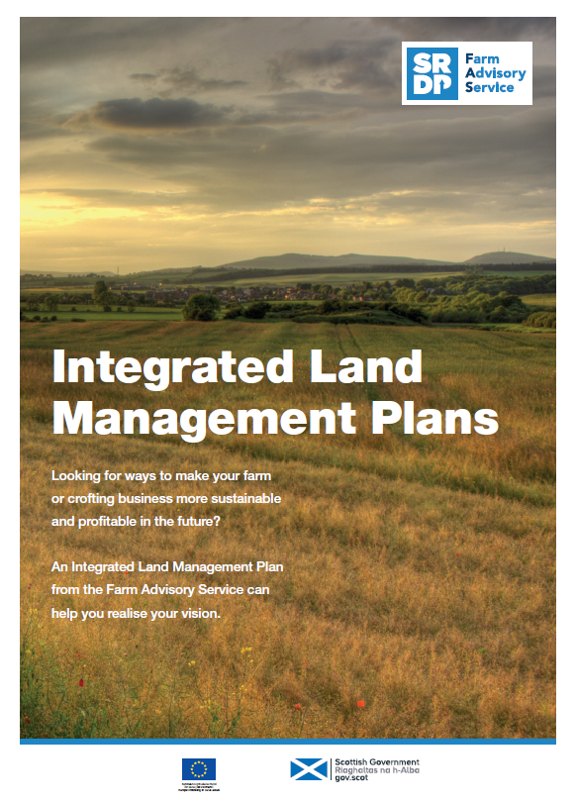

Promotional postcards made available at trade stands
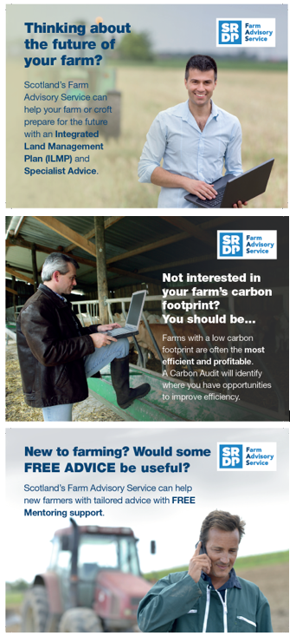

Support for new entrant’s flier sent as direct mail
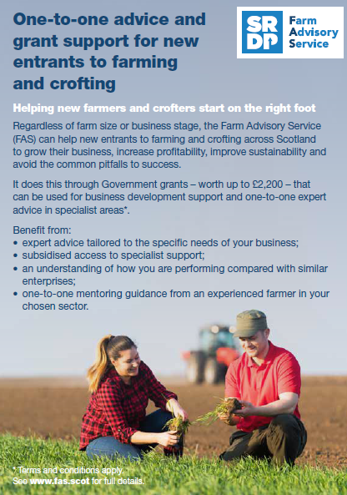

Case Studies
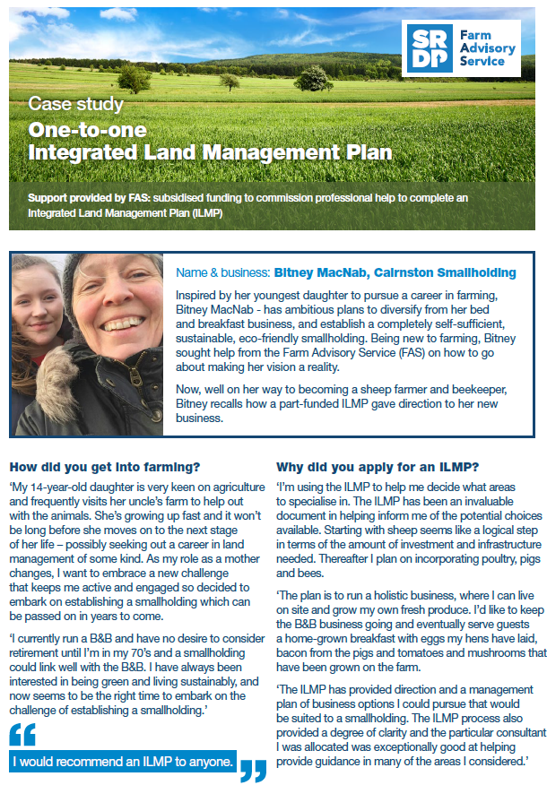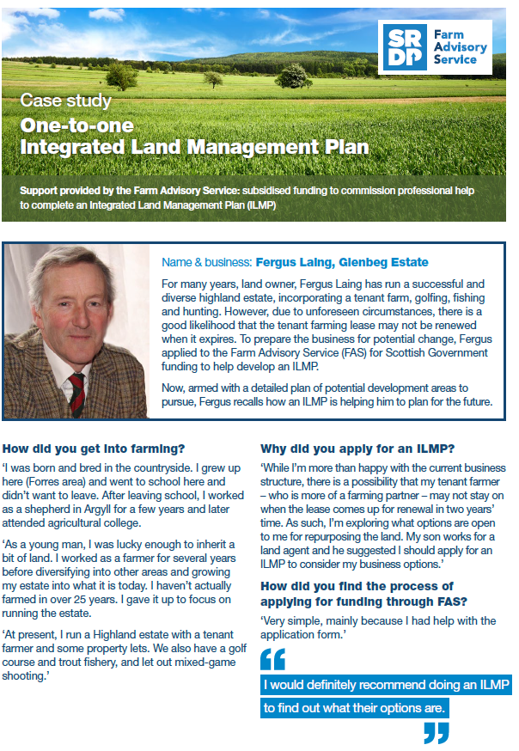

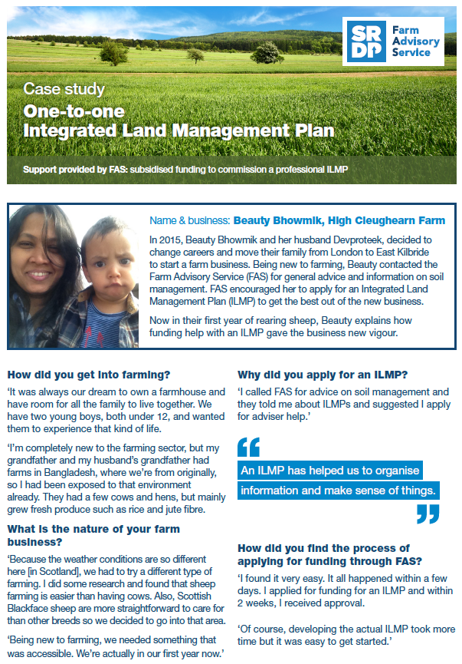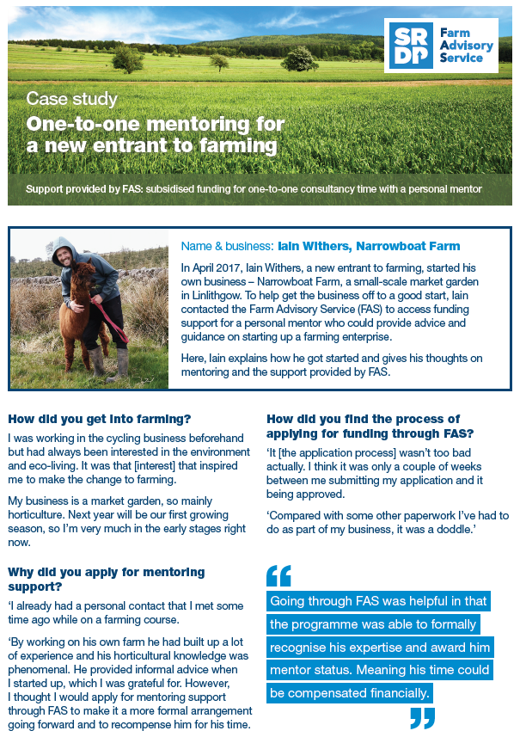

Introductory slides
A brief pack of 8 slides have been produced to introduce the One-to-One service, these were circulated to SAC to incorporate into the One-to-Many events.

Show attendance
- June, Highland Show, Ricardo and SAC represented FAS at the Highland Show. We received a number of enquiries from farmers and some useful engagement. The show was particularly valuable for the opportunities to engage with stakeholders and advisers and some very useful leads were generated.
- The One-to-one Programme had both a stand and material in the delegate pack at the New Entrants to Farming Conference on the 27th February at Perth Racecourse. Kirsten Williams who hosted the day highlighted to farmers the support available and directed interested parties to the stand. This lead to many enquiries and in-depth discussions of how the support could be utilised in the farmer’s specific circumstance. This was a very worthwhile event. Caroline has followed up with Kirsten, and offered to attend any regional ‘entrants’ meetings.

Stakeholder meetings
- SOAS, April 2017, following an introduction by Keith McWhinnie, Hugh Martineau and Ian Riddell met with Emma Patterson Taylor and Stuart Martin on the 19th April. This was a very valuable meeting the Dairy Hub did not previously have a full understanding of the support available to farmers via the FAS and so it was important to understand and reinforce the linkages.
- Sheep and Trees, April 2017, Hugh Martineau and Caroline Wood had a meeting with Henry Graham on the 20th April. The launch of the sheep and trees project has been delayed due to purdah restrictions. Henry provided Ricardo with some forestry contacts with whom to follow up with the aim of developing adviser training material.
- Briefing of SAC specialist advisers, May 2017, Caroline Wood provided a briefing to SAC’s specialist advice team leaders on the 12th May. To ensure the teams understand the remit of specialist advice and are communicating this appropriately with farmers. We also wish to encourage specialist advisers to submit their CVs to the programme.
- Briefing of SAC southern advisers, May 2017, Caroline Wood and Hugh Martineau provided a briefing to SAC’s southern advisers at their team meeting on the 25th May. The aim is to ensure the One-to-one services are at the front of their mind as they go out to meet clients and to ensure that there is a good understanding by all advisers (not just FBAASS accredited advisers) of the level and flexibility of support available.
- Hugh Martineau participated in the education group, chaired by Scottish Government Agriculture Champion, Henry Graham. There was a great deal of interest and enthusiasm for what FAS can offer. In particular, mentoring was a major theme of discussion.
- FAS One-to-One and One-to-Many jointly presented to SNH advisers in Perth, 19th June. This was a really useful meeting, there was a lot of engagement from SNH staff and clear opportunities for the FAS to compliment the work delivered by SNH.
- Caroline Wood provided a briefing to SAC’s new entrants team leaders at their team meeting on the 27th June. The aim was to ensure that these advisers are knowledgeable of the support available through the one-to-one service and able to promote this through their engagement with new entrants.
- Hugh Martineau has been working with John Duggan (Forestry Commission) to establish how the FAS service can support the Sheep and Trees initiative. As a first step, John provided speakers to the FAS Adviser training events.
- Webinar with SEPA delivery team, July 2017. Ricardo delivered a teleconference/webinar to brief SEPA advisers on the remit and delivery under FAS on the 3rd July. This was very useful, SEPA really saw the value of the support ILMPS and follow up specialist advice in soil and water management could offer farmers in diffuse pollution catchments.
- Following advice from the steering group Ricardo engaged with Ringlink and Jim Booth shared material that had been developed to help support good mentoring practice. This provided some very useful guidance on how to approach mentoring and the kind of behaviours expected of mentors. Utilising this material, the mentoring procedures document was updated.
- Meetings in August with John Duggan and Keith Wishart, (Central Scotland Conservator), established a number of actions to support and promote the Sheep and Trees project and on-farm woodland creation.
- 31st August, Ricardo met with Mags Granger regarding an initiative RSABI are working on with NFUS, the Dairy Hub and the Animal Plant and Health Agency. This is to develop a support package for farmers with welfare issues. Mags wants to explore how this links with the work we deliver under the FAS and what support could be provided via the helpline. The partners wish to provide a telephone number which people concerned about the animal welfare on a farm can call and trigger some support to the farmer. However, whilst the helpline number is easy, the fact is that no organisation would have the authority to go out to the farm and undertake any follow up activity without the farmer’s consent. Since this meeting, Richard Huxtable (RSABI) has been in touch regarding the potential to extend the hardship arrangements to cover farmers with critical livestock welfare issues. Scottish Government agreed to this and the terms of agreement with RSABI were updated.
- Presentation to Zero Waste Scotland, Caroline met with ZWS sector managers on the 29th August. Zero Waste Scotland were keen to understand the support to farmers available through the programme with regards to waste reduction and management and to identify if there were gaps in the support that they could/should address.
- 11th December, Meeting with David Freeman, AIC, Hugh Martineau and Caroline Wood met with Dave Freeman to discuss how AIC could help promote awareness of the FAS Scotland One-to-one service. Dave has been sent the stakeholder pack and will receive all further editions
- Caroline Wood delivered a presentation on the FAS support available to farmers at the Tyne Esk LEADER Farm Diversification Event at the National Mining Museum Scotland on the 20th February. The farmer attendance at the event was a little disappointing, there were 23 attendees, but a number were stakeholders and advisers. It was a useful event for engaging with stakeholders such as Alan Laidlaw and Jamie Farquhar (Confor) who both receive our stakeholder communications. Feedback from Leader is that they too are experiencing a real lack of momentum in the farming sector and are concerned about the current lack of interest in support available

Direct mail
Ricardo delivered a targeted campaign to encourage new entrants to take up the mentoring service. Robert Logan (SAC) and his regional team provided a contacts database of farmers who have come through the New Entrants to Farming Programme in recent years. The data was of variable quality, we therefore spent some time doing web research to fill the gaps in some of the address data. The flier was posted during the week of the 16th October to 219 contacts and a complimentary email campaign was sent to 343 contacts.

Social media feed
Since August 2017 Ricardo have provided Will Searle, SAC with a twitter and social media schedule, this provides one-to-one content for two tweets per week. Will, issues these via the FAS account

Stakeholder pack
A stakeholder pack http://fas-scot.com/t/DA4-5BNRN-R60YXZ-2X03UL-1/c.aspx containing links to all FAS press resources, case studies, press releases, articles and flyers has been developed and the first of these was sent to our list of stakeholder contacts in December, a new pack will be drafted on a quarterly basis. The premise of the stakeholder pack is to provide information in order that stakeholders can pick and choose relevant material for inclusion in their own publications.

Website
Ricardo have provided comment and information on the One-to-one service for inclusion on the FAS website. Having jointly reviewing the staging of the new website, we identified that many of the topic areas were also serviced by specialist advice. Ricardo provided boiler plate text to appear on each of these topic pages to link readers back to the specialist support available.

RSABI support
Following contact from RSABI both to FAS and directly to Fergus Ewing a meeting was convened in April to agree mechanisms by which RSABI will refer farmers in crisis for support. It was agreed that RSABI would act as a gatekeeper and would assess requirements and refer on to FAS for specialist advice farmers who they have discerned require emergency assistance. It was agreed by Scottish Government that in these limited circumstances farmers will be allowed access directly to specialist advice without the need for a prior/or corresponding ILMP. The specialist advice will receive up to 80% funding up to a limit of £1,000.

Volume of RSABI reports
To date there have been 17 farmers who have received specialist advice via the RSABI support mechanism.

RSABI pilot of feed resilience advice
In December, Scottish Government agreed to provide 100% funding (up to £1,000) for, RSABI to run a pilot to establish the impact of providing specialist advice on feed resilience to farmers identified as being in need. If the pilot shows that this intervention is worthwhile RSABI will in future include this in their hardship support and run the normal model of the grant covering 80% of the costs with RSABI, or farmer covering the rest.

Payment Mechanisms

Approach to payment
Ricardo administer the payments directly to advisers on the Scottish Government’s behalf. Ricardo operate a separate bank account with funds being drawn down into the dedicated bank account in accordance with financial profiling. We have developed this process to ensure the following:
- No monies are awarded without evidence of the work being completed or support being provided (evidence saved onto the CRM).
- All monies to be paid in arrears.
- The monies are ring-fenced and separated from Ricardo’s own accounts.

Overview of payment transfers
In the period 31/03/17- 30/02/18 Ricardo administered 15 pay-runs, delivered on a rolling 4 weekly cycle. During this period £184,910 was transferred to advisers for work completed.

Template updates

ILMP template update- diffuse pollution SEPA
Following a discussion with Darrell Crothers (SEPA) regarding how the ILMP covers Soil Management and Diffuse Pollution Ricardo amended the ILMP template to include a sub section to the nutrients and soil section in relation to pollution prevention. The guidance document was updated to show what is expected in this section. Advisers were notified of this change in the May 2017 newsletter and the new template was then individually emailed to each adviser.

Application form updated to include details of ownership
The application form was revised in November to include a question on tenancy status as requested at the stakeholder meeting.

Metrics of delivery during the year
During the period up to June the number of applications for ILMP increased on a monthly basis as the programme gained momentum. However, since this point we have seen a ramping down of demand, this is despite a sustained effort to market and promote the service both directly to farmers and via stakeholders. The feedback from advisers and stakeholders is that Brexit has caused a hiatus, farmers are holding back from making any business decisions at this time and this is impacting on their uptake of advice. Ricardo have sought to counter this and a press article was circulated in early April addressing the fact that whatever the future holds, a business that has taken steps to ensure it is as efficient as possible is best placed to deal with change. This is a message we will continue to promote.

Applications received
 |  | Applications received |  |  |  |  |  |  |  |  |  |  |  | Total in 2017/18 | Targets for year
 | Total received up to 31 March 2017 (2016/17 Business Plan) | April | May | June | July | August | September | October | November | December | January | February | March
ILMP | 92 | 5 | 14 | 21 | 7 | 25 | 7 | 13 | 11 | 5 | 8 | 6 | 3 | 125 | 300
Specialist Advice | 106 | 21 | 18 | -1 | 22 | 25 | 23 | 19 | 16 | 22 | 14 | 12 | 9 | 214 | 100
Carbon Audits | 106 | 2 | 17 | 35 | 10 | 29 | 15 | 13 | 17 | 11 | 1 | -4 | 4 | 150 | 250
Mentoring | 15 | 4 | 1 | 5 | 0 | 0 | 2 | 3 | 2 | 0 | 1 | 1 | 1 | 16 | 60

Graph to show delivery to date for the programme

Reports complete
 |  | Reports complete |  |  |  |  |  |  |  |  |  |  |  | Total in 2017/18 | Targets for year
 | Total received up to 31 March 2017 (2016/17 Business Plan) | April | May | June | July | August | September | October | November | December | January | February | March
ILMP | 10 | 0 | 6 | 4 | 7 | 14 | 2 | 25 | 8 | 7 | 3 | 5 | 4 | 85 | 300
Specialist Advice | 2 | 0 | 1 | 10 | 8 | 10 | 1 | 16 | 3 | 9 | 6 | 9 | 3 | 76 | 100
Carbon Audits | 0 | 0 | 2 | 7 | 3 | 5 | 1 | 13 | 11 | 10 | 26 | 27 | 25 | 130 | 250
Mentoring | 15 | 4 | 1 | 0 | 2 | 0 | 2 | 3 | 2 | 0 | 1 | 1 | 1 | 16 | 60

Graph to show delivery to date for the programme

Feedback summary
Feedback from farmers to date has been excellent and provides a compelling message for farmers that the advice is of a high standard and a clear benefit to businesses.
- 91% rated ease of access to information as excellent or good;
- 95% rated helpfulness at initial contact point as excellent or good;
- 92% rated ease of application process as excellent or good;
- 92% rate efficiency of scheme administration as excellent or good;
- 87% stated that based on their experience, they would recommend the FAS grants to other farmers;
- 96% rated the adviser’s working practices (helpfulness, understanding, expertise, etc) as excellent or good;
- 95% rated the quality of the report/support as excellent or good;
- 88% confirmed that they will implement all of the actions recommended.

A detailed breakdown of the metrics for each individual advice stream will be provided in a separate analytical report.

Budgetary analysis

 | 12 month targets | Achieved | pipeline spend | Budget
ILMP | 300 | 125 | £150,000.00 | £360,000.00
Specialist Advice | 100 | 200 | £200,000.00 | £100,000.00
Carbon Audits | 250 | 150 | £75,000.00 | £125,000.00
Mentoring | 60 | 16 | £16,000.00 | £60,000.00
Total |  |  | £441,000.00 | £645,000.00

With the drop in applications since June the programme has ended the year at 68% of capacity. The number of specialist advice applications is 100% over target, however the ILMP application rate is 41% of the target. This is disappointing as up to June the programme seemed to be gaining real traction but has seen a slowdown in applications from this point forward.

The Gemini Building
Fermi Avenue
Harwell
Didcot
Oxfordshire
OX11 0QR
United Kingdom
t: +44 (0)1235 753000
e: enquiry@ricardo.com
ee.ricardo.com

