Basic Payment Scheme Greening Rules – Reminder
Crop Diversification

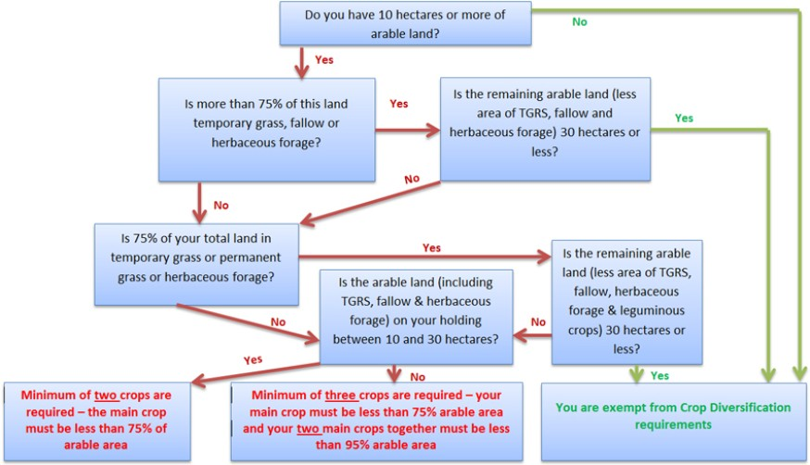

Ecological Focus Areas (EFA’s)
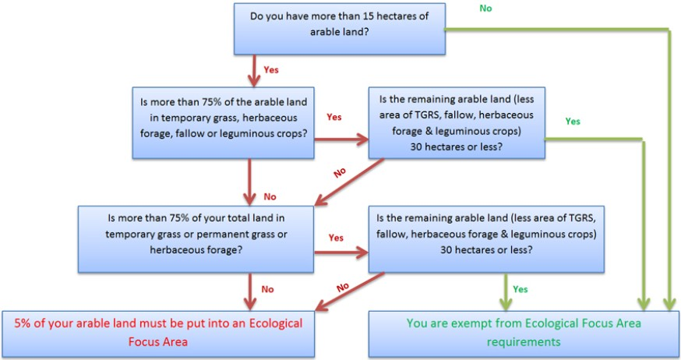

Arable land includes:
Arable Cropping
Temporary Grassland
Fallow & Field Margins/buffer Strips
Areas in Agri Env Scheme that were previously arable e.g. beetle banks

EFA = 5% of total Arable land

Options for EFA requirements

 | Weighting |  | Main Points
Fallow | 1.0 |  | Exclusion 15th Jan - 15th July
Grass Margins | 1.5 |  | Exclusion 1st Jan – 31st Dec
Buffer strips | 1.5 |  | Exclusion 1st Jan – 31st Dec
Nitrogen Fixing Crops | 0.7 |  | Sow N Fixing crops (at least 2)
Catch Crops | 0.3 |  | Undersow a Cereal Crop
Green Cover Crops | 0.3 |  | Sow a Cover crop before 1st Oct

