Grassland Sward Measuring Stick
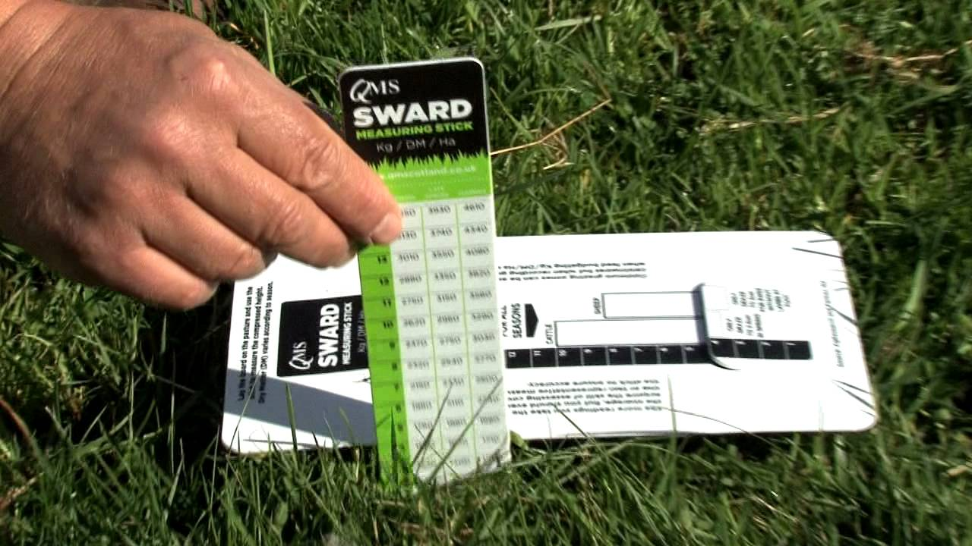
Join The Grassland Revolution!
Contact QMS to get your sward stick
Tel: 0131 472 4040 or email info@qmscotland.co.uk
Grassland Sward Measuring Stick
Join The Grassland Revolution!
Contact QMS to get your sward stick
Tel: 0131 472 4040 or email info@qmscotland.co.uk

