The Importance of Rotations and Soil pH

Organic systems rely heavily on rotations and the use of legumes to fix nitrogen (and there has been renewed interest in both rotations and legume use in conventional farming). It has been found that relatively small shifts in pH can have a major effect on sward composition of grass and clover leys. There is a dramatic reduction in the clover component of such swards when the soil pH starts to fall below around 5.7, so if nitrogen fixation is a key part of the system’s nitrogen management, and therefore overall productivity, the soil pH needs to be monitored closely.

SRUC has been running a replicated legume-based trial at Tulloch near Aberdeen since the early 1990s. At the start this looked at two stocked six year rotations then in 2007 two stockless rotations were added.

All the plots were limed in 2007 to raise the pH to just above 6. The soil pH of the plots has been tested in the late winter every year since then. It has been found that the liming raised the pH as anticipated but it did take approximately four years to have maximum effect. The sequence of crops in the rotation has also been shown to have a big effect on the soil pH over time.

The stocked system appeared to maintain soil pH at a slightly higher level than the stockless system, although this was marginal and was influenced by cropping sequence. It does suggest a slight liming effect of manuring through either FYM applications or grazing. What was clear was that the two different rotations within each system did show strongly contrasting shifts in soil pH over time. The stockless rotation that had spring wheat followed by potatoes tended to retain a higher soil pH for longer than the rotation that had potatoes followed by spring wheat. The socked rotation that had spring oats as the cereal immediately after the grass-clover ley retained a higher soil pH for longer than the rotation that had spring barley at this point. Although the differences are no more than 0.2 of a pH unit for any one year, the difference is apparent over several years. (See graph below).

The actual rotations are just illustrative, but what can be taken from the trial is that, given that small shifts in pH can have a major impact on the productivity and nitrogen fixing potential of legumes, any cropping system that is reliant on nitrogen fixation clearly needs to monitor soil pH regularly. Also, rotation affects how quickly soil pH falls. Testing the pH routinely will highlight if soil pH is shifting away from the optimum for legume growth, allowing intervention to take place in order to maximise the nitrogen fixing potential of the system, and therefore the productivity of all the crops within the rotation. The use of pH mapping and variable lime application approaches may prove to be beneficial and cost effective, particularly in terms of legume-based crop system efficiency.

If you would like more information about the trial please get in touch.

Stockless Stocked

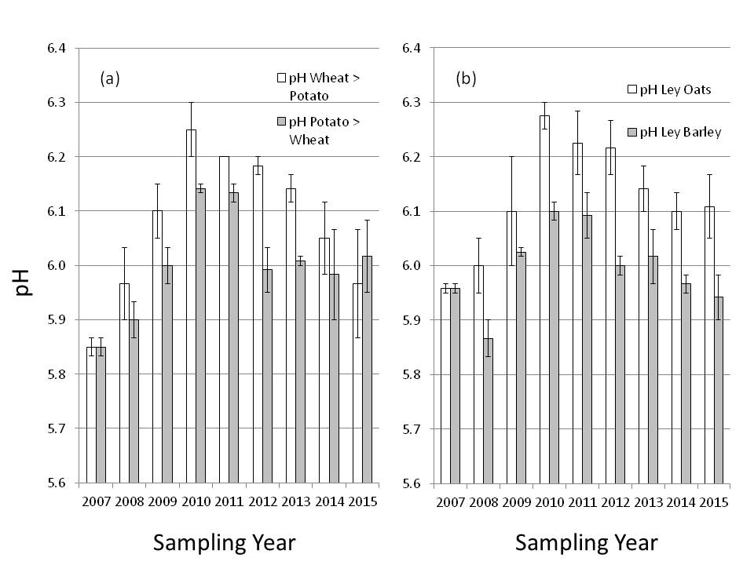

Figure. Soil pH (0–15 cm) measured annually pre-ploughing from 2007 until 2015. (a) represents the average pH across each 6 year rotation in each sampling year for the two stockless systems (wheat followed by potato, or potato followed by wheat, with all other crops in the rotational sequence the same), and (b) represents the average pH across each 6 year rotation in each sampling year for the two stocked systems (oats after grass-clover, or barley after grass-clover, with all other crops in the rotational sequence the same).

Reference
R L Walker & C A Watson (2016) Impact of crop sequence on pH changes in a long-term legume based rotation experiment. Conference proceedings of ESA 14 - Growing landscapes – Cultivating innovative agricultural systems 5-9 September 2016

Aileen Buchanan, Senior Consultant/Area Manager, SAC Consulting
& Robin Walker, Crop & Soil Systems Research Group, SRUC

